**Design & Technology**

**

**Systems approach to designing**

**Materials required for questions**

* Pencil
* Rubber
* Calculator

**Instructions**

* Use black ink or ball-point pen
* Try answer all questions
* Use the space provided to answer questions
* Calculators can be used if necessary
* For the multiple choice questions, circle your answer

**Advice**

* Marks for each question are in brackets
* Read each question fully
* Try to answer every question
* Don’t spend too much time on one question

**Good luck!**

**Q1.** Which component is the output in a temperature warning system?

**A** Lamp

**B** Switch

**C** Temperature sensor

**Q2.** What is the electrical component shown used for?

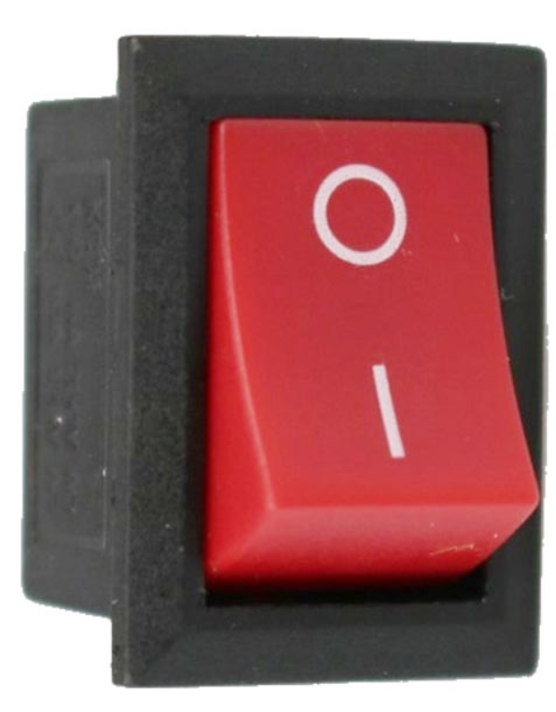

**A** To detect pressure levels

**B** To switch equipment on or off

**C** To switch the direction of a motor

**Q3.** **.** Which component is the input in a temperature warning system?

**A** Lamp

**B** Switch

**C** Temperature sensor

**Q4.** Which of the following is **not** an input for a system?

**A** Light sensors

**B** Pressure sensors

**C** Timers

**Q5.** Complete the system for an intruder alarm system **(3 marks)**

Input block:

Process block:

Output block:

**Answers**

**Q1**. A

**Q2**. B

**Q3**. C

**Q4**. C

**Q5.**

Inputs:

* Light sensors
* Temperature sensors
* Pressure sensors
* Switches
* Pressure pad

Processes:

* Microcontrollers
* Timers
* Decision making

Outputs:

* Buzzers
* Speakers
* Lamps